**PDA Evidence - Chris Burn, G2 Cohort**

**Week 2:**

*Demonstrate the use of an array in a program. Take screenshots of:*

*\*An array in a program*

*\*A function that uses the array*

Two Arrays or strings, pulled into “add_length_of_arrays” method

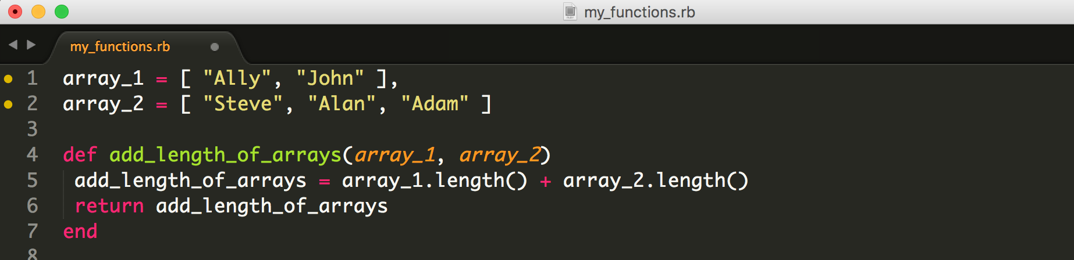

*\*The result of the function running*

Shows TDD testing of method through MiniTest and result of MiniTest in Terminal...

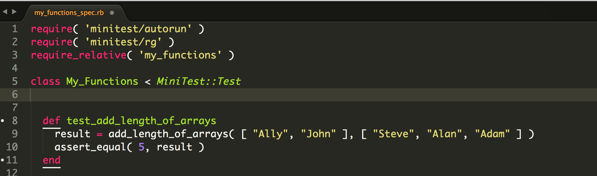

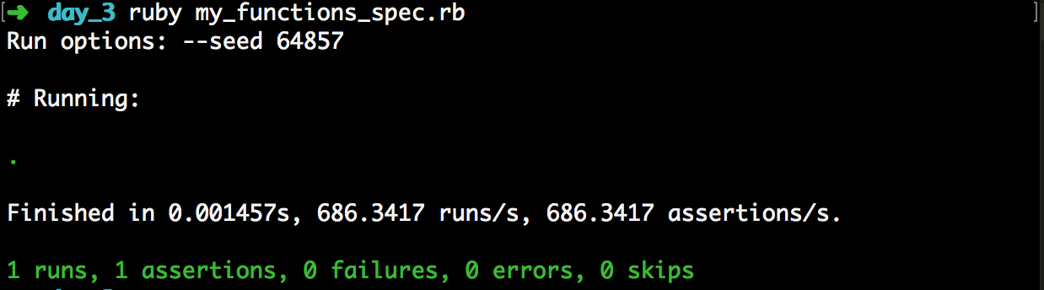

*Demonstrate the use of a hash in a program. Take screenshots of:*

*\*A hash in a program*

*WITH*

*\*The result of the function running*

Hash and an Array with in-built Hashes, WITH testing of function (separate) via MiniTest

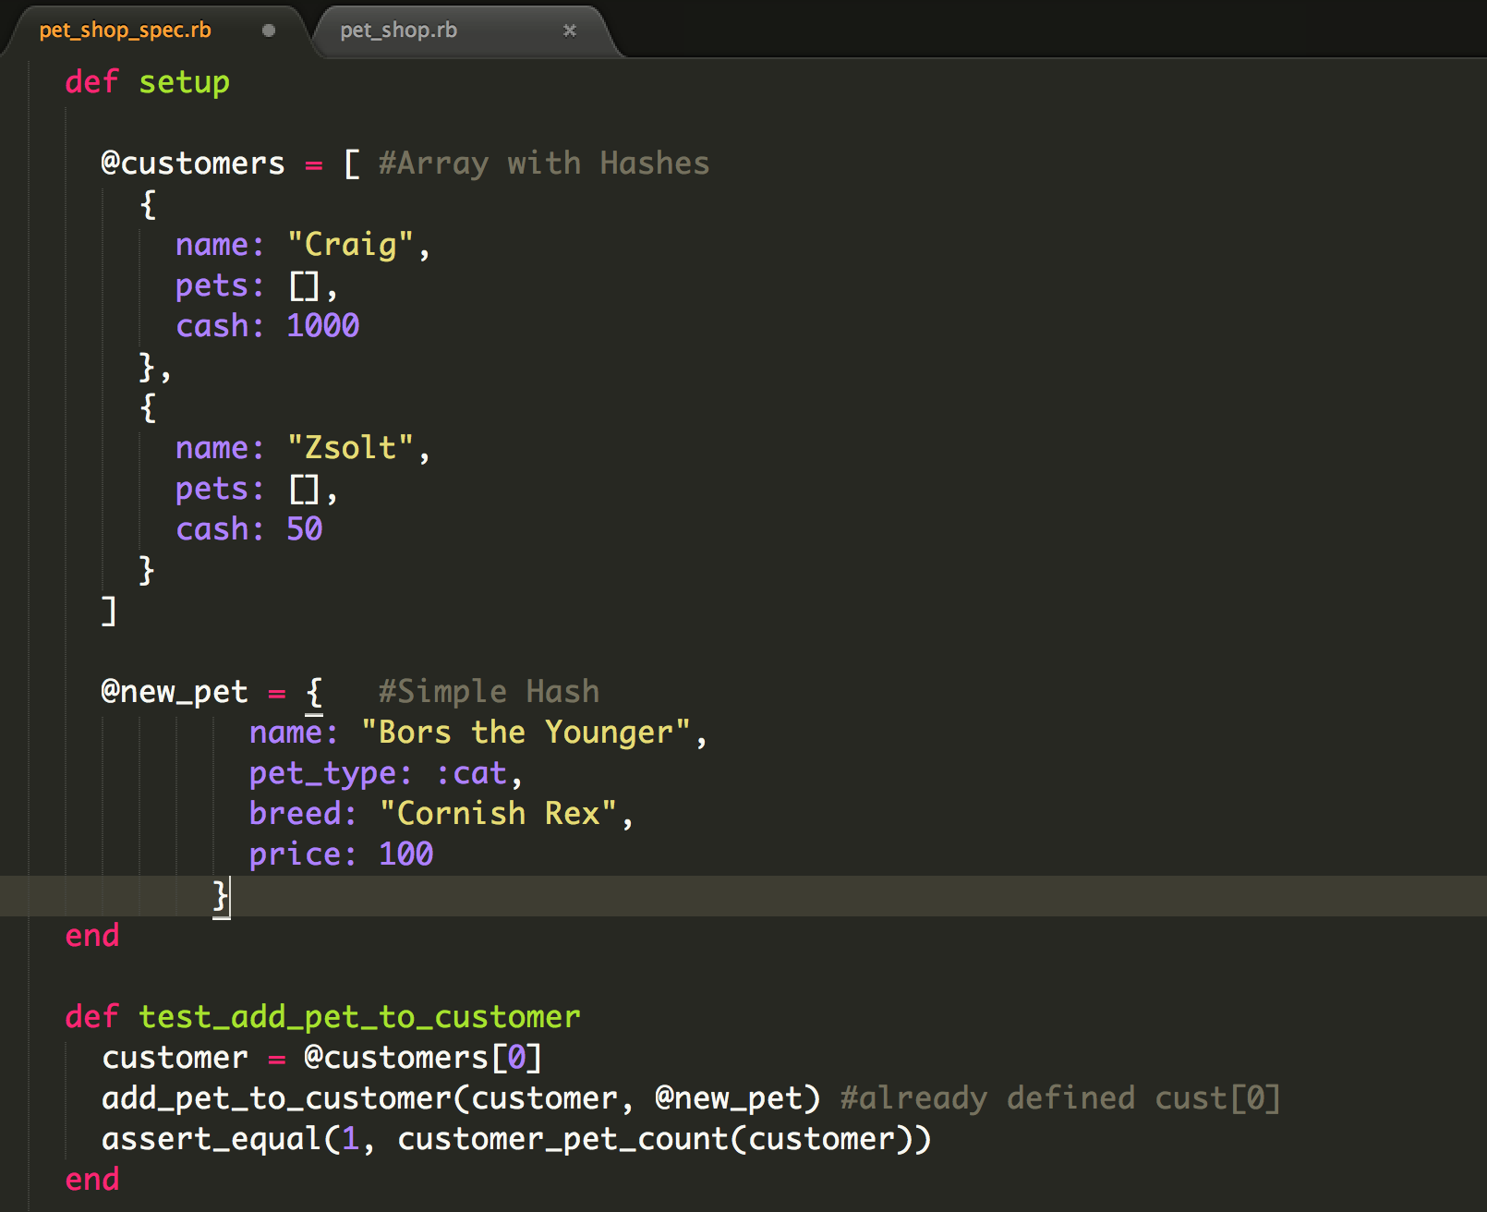

*\*A function that uses the hash*

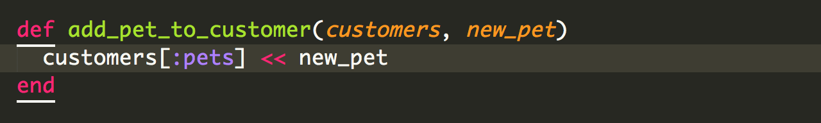

**Week 3:**

**Demonstrate searching data in a program. Take screenshots of:**

**\*Function that searches data**

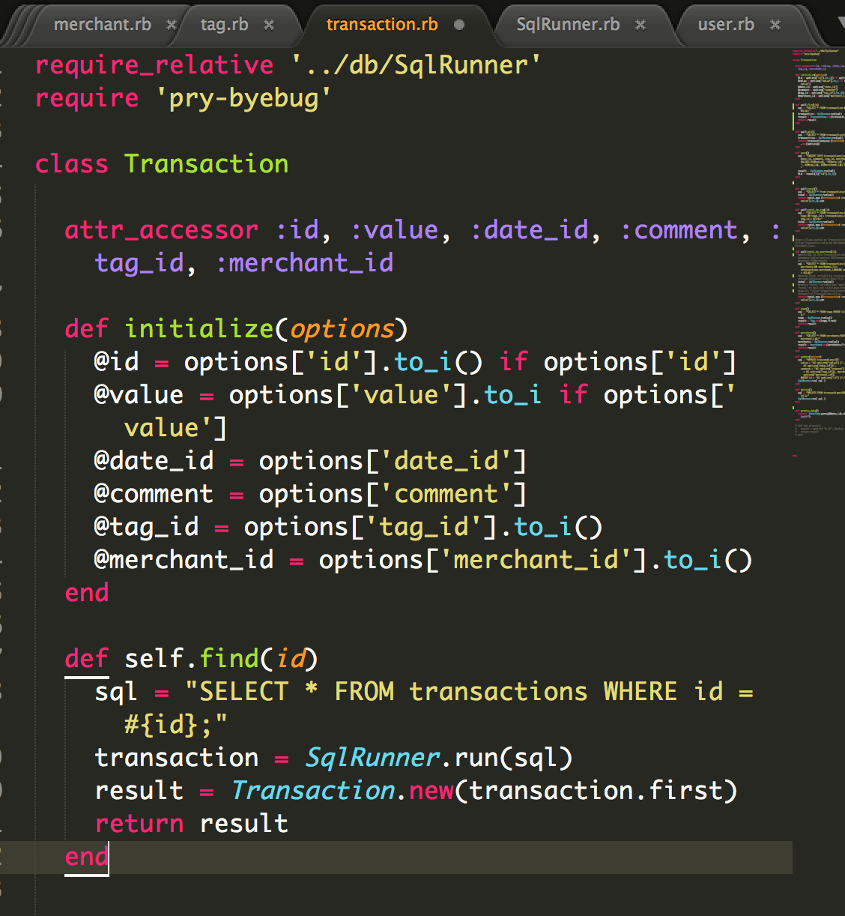

**\*The result of the function running**

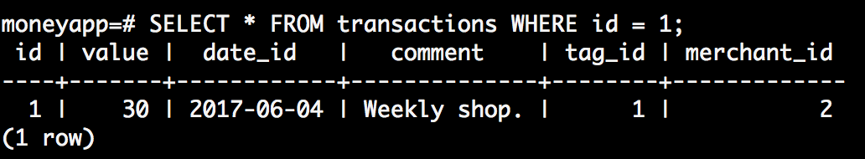

**Demonstrate sorting data in a program. Take screenshots of:**

**\*Function that sorts data**

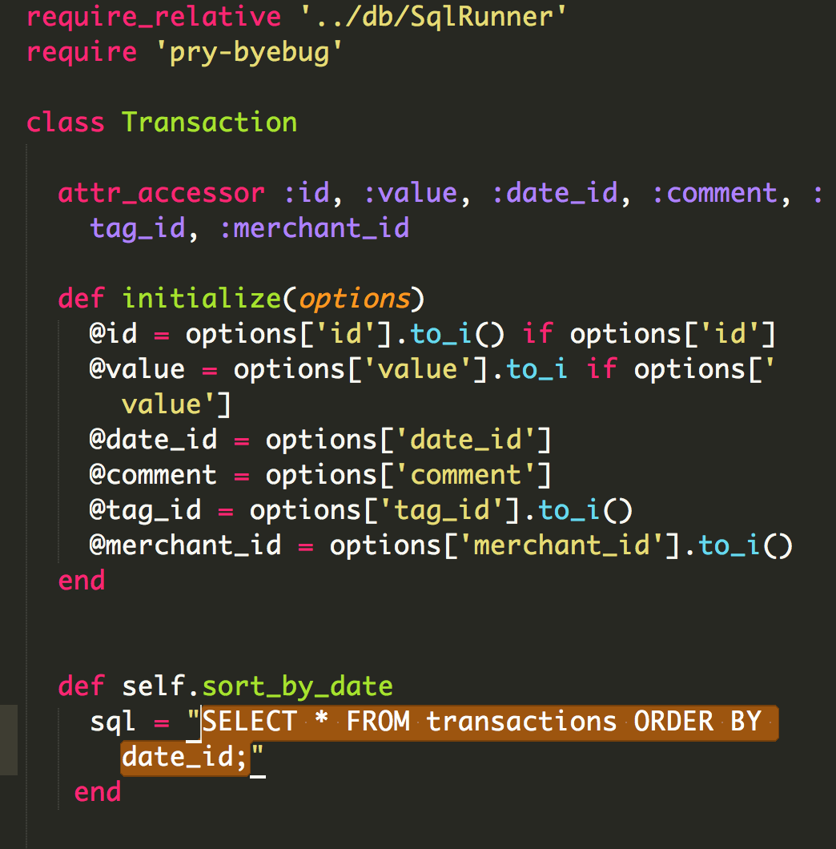

**\*The result of the function running**

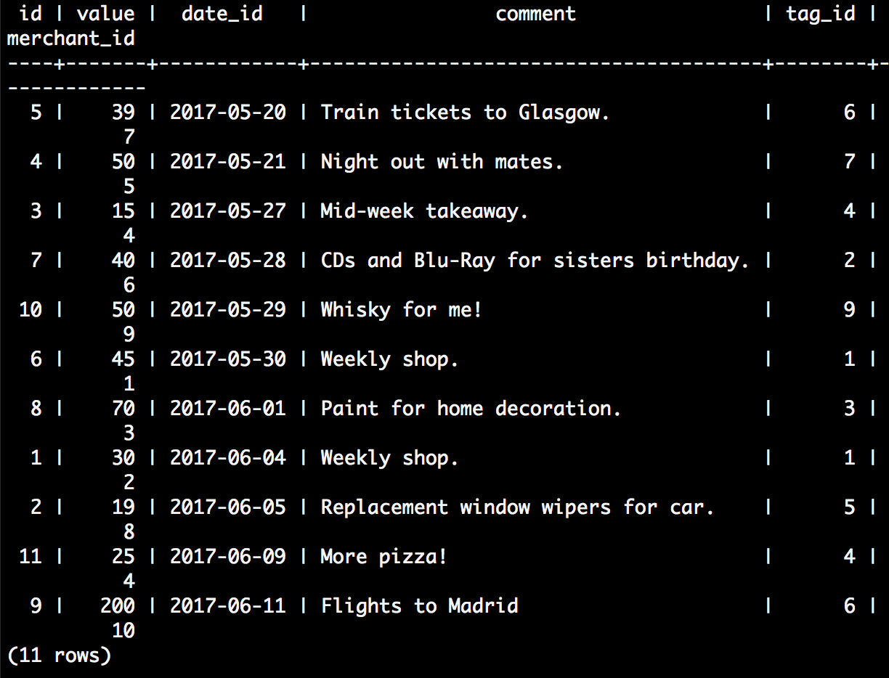

**Week 5:**

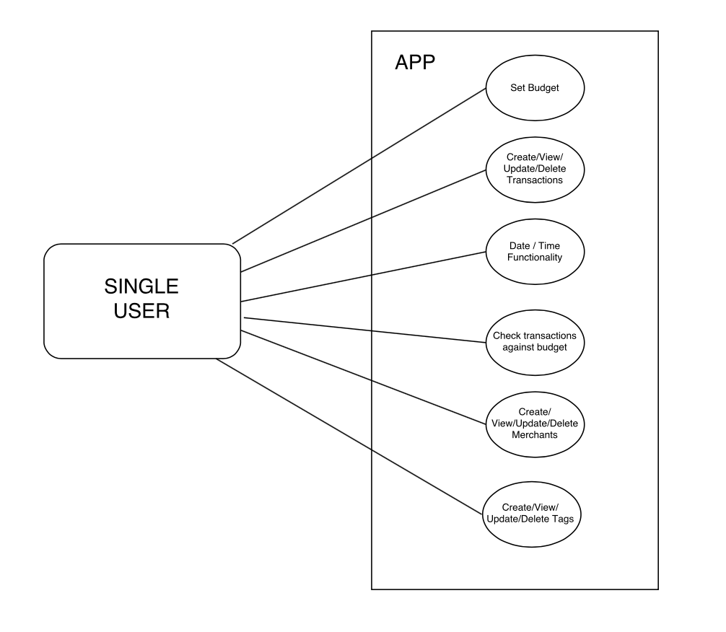

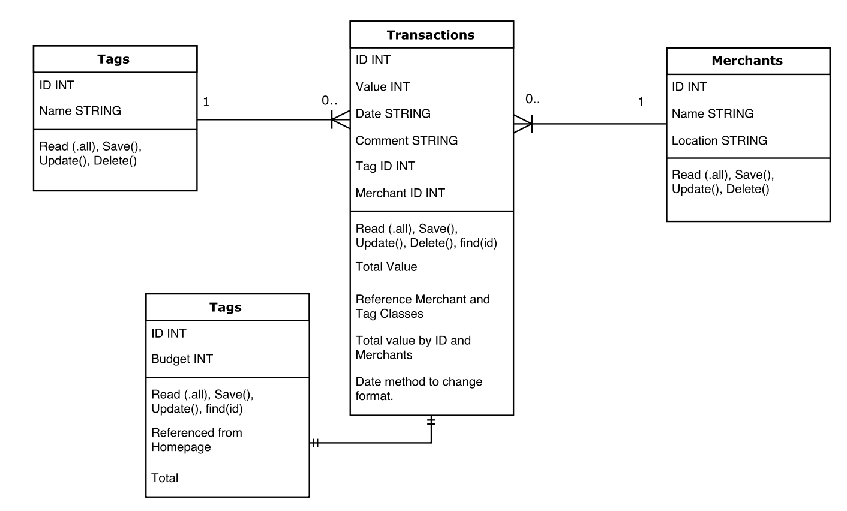

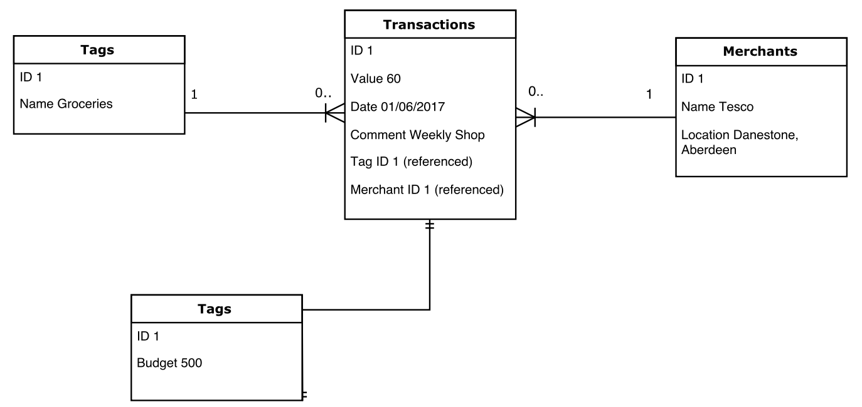

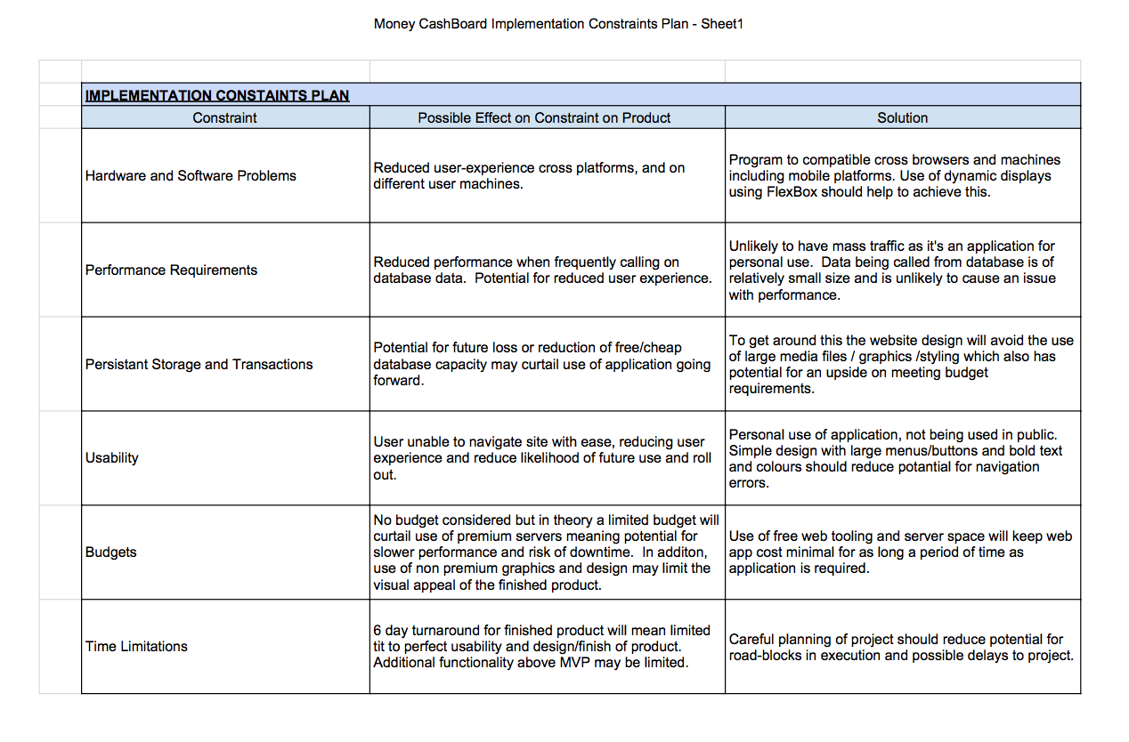

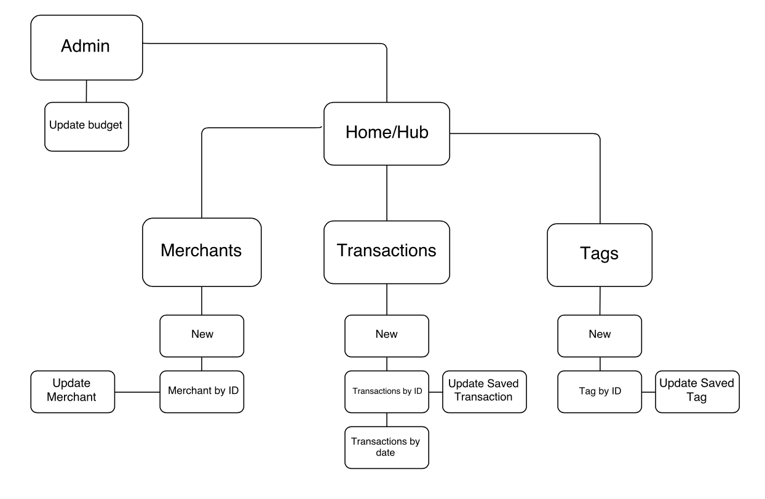

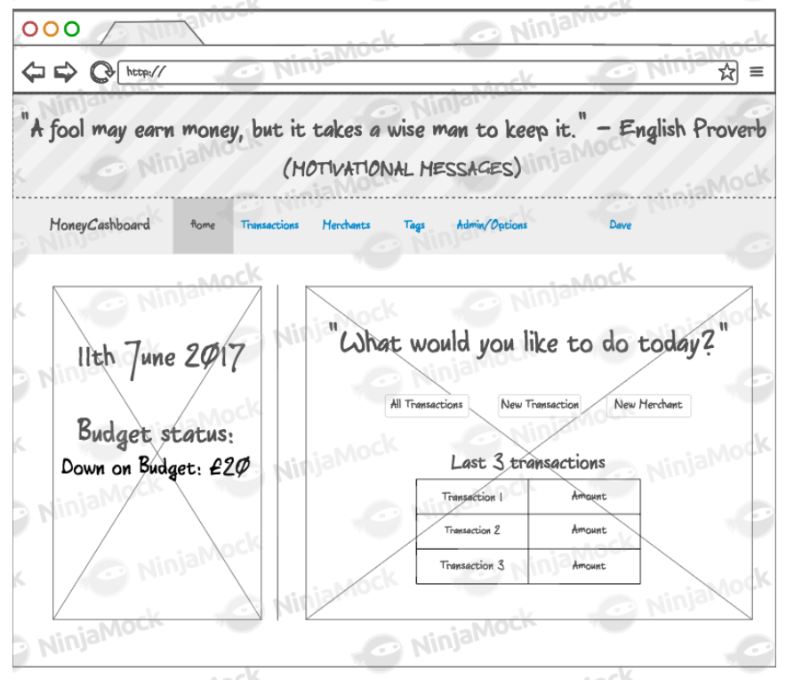

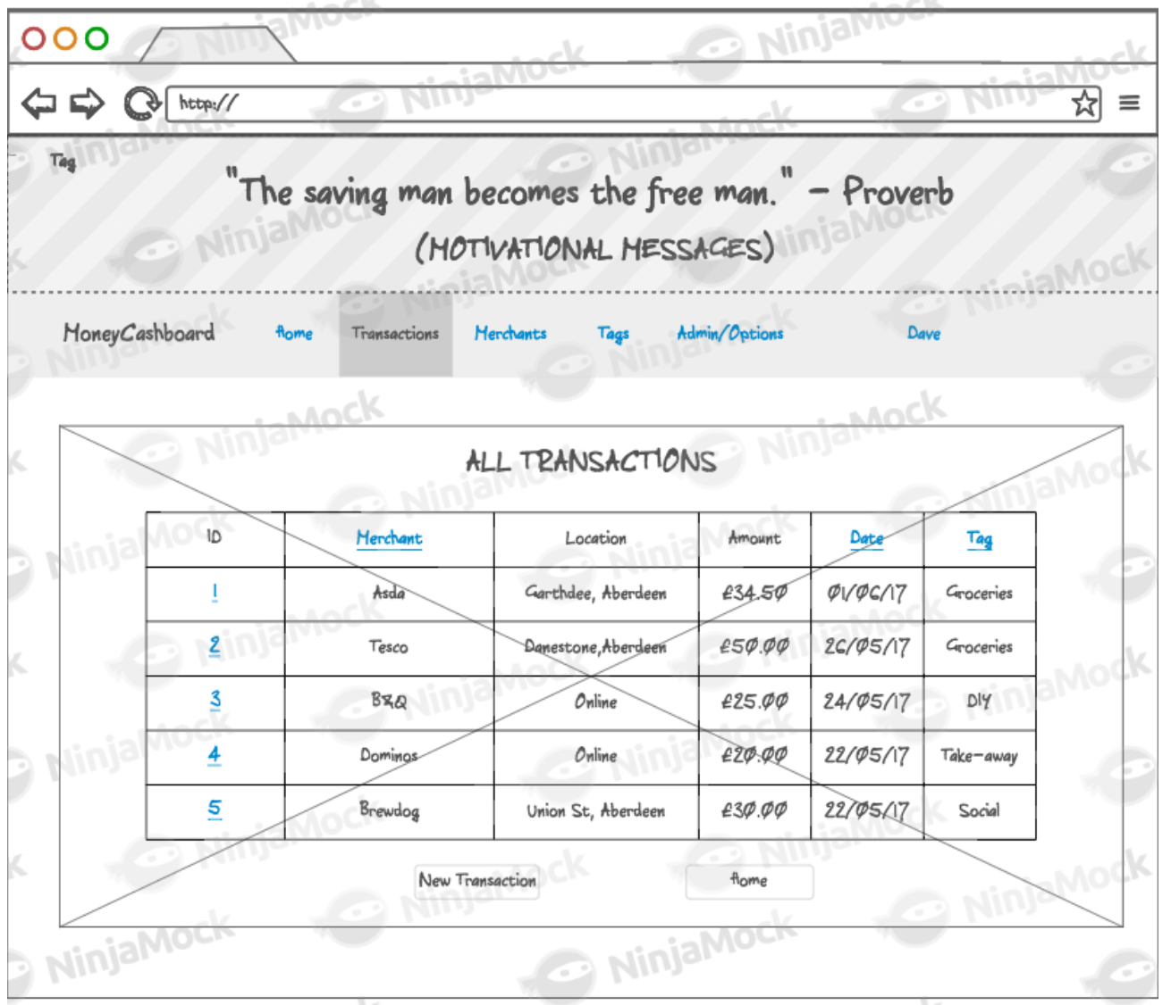

Psudo-code example showing a method calling on the result of an INNER JOIN on two database tables:

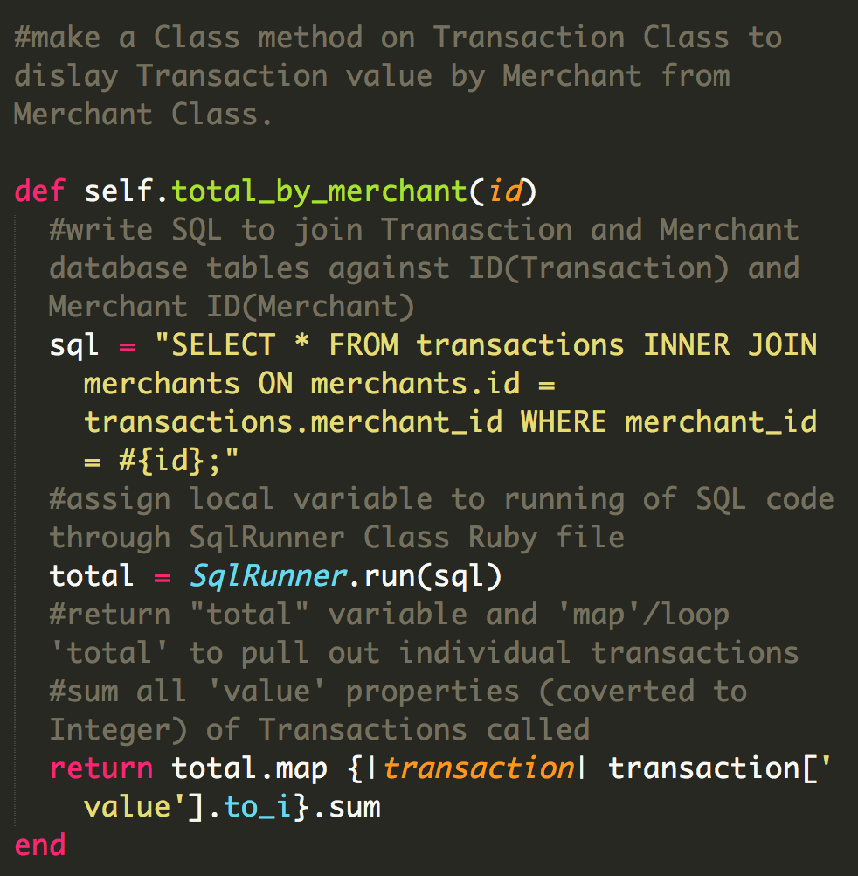

**Show user input being processed according to design requirements. Take a screenshot of:**

* The user inputting something into your program

* The user input being saved or used in some way

**Show an interaction with data persistence. Take a screenshot of:**

* Data being inputted into your program

* Confirmation of the data being saved

**Show the correct output of results and feedback to user. Take a screenshot of:**

* The user requesting information or an action to be performed

* The user request being processed correctly and demonstrated in the program

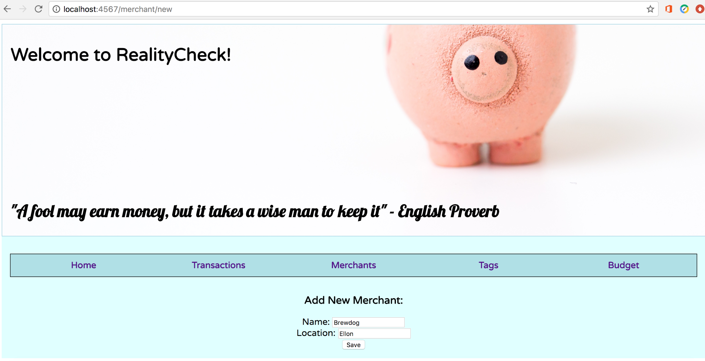

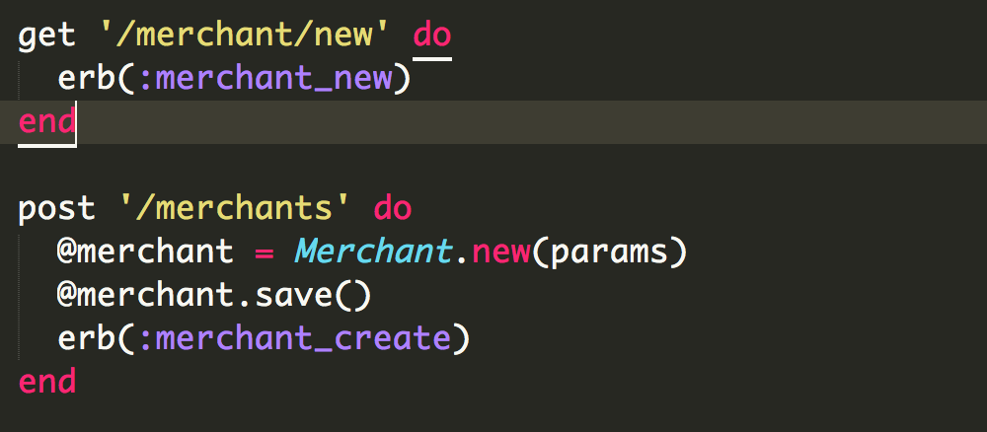

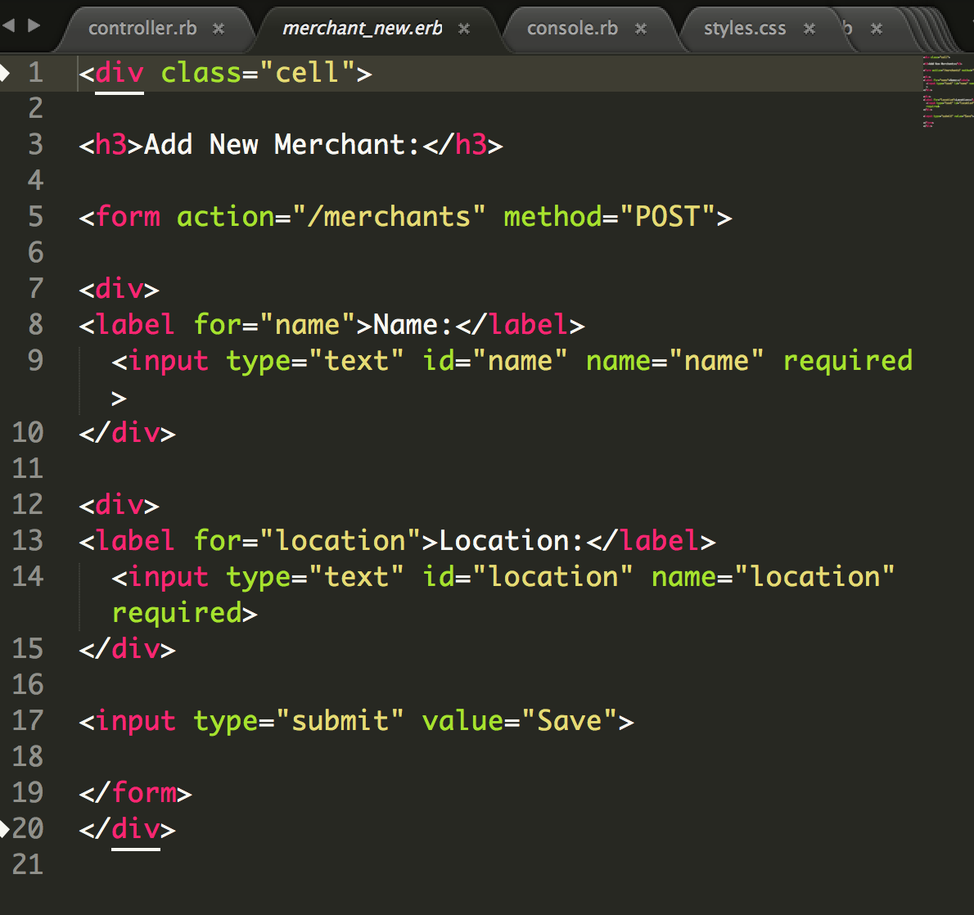

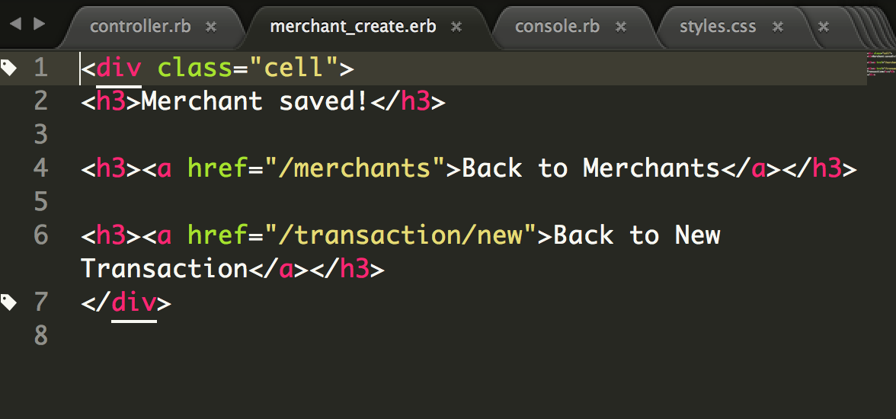

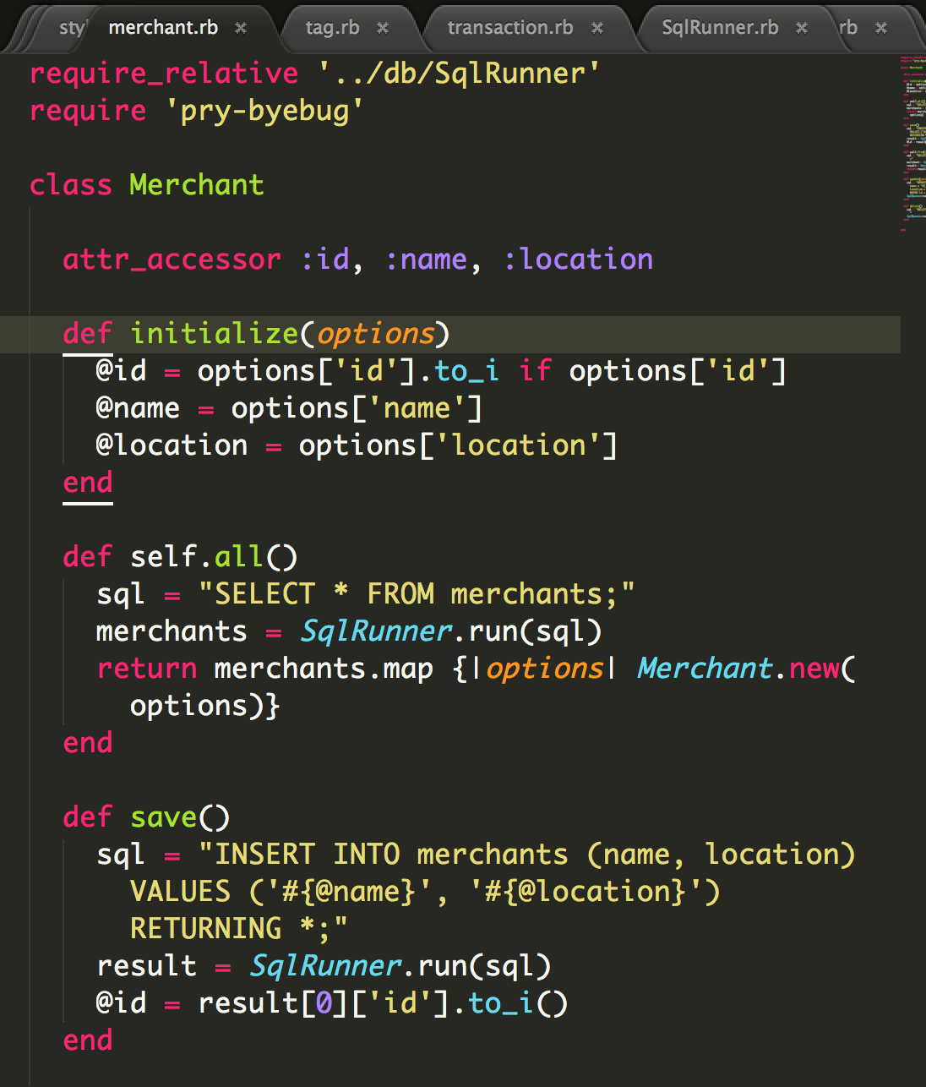

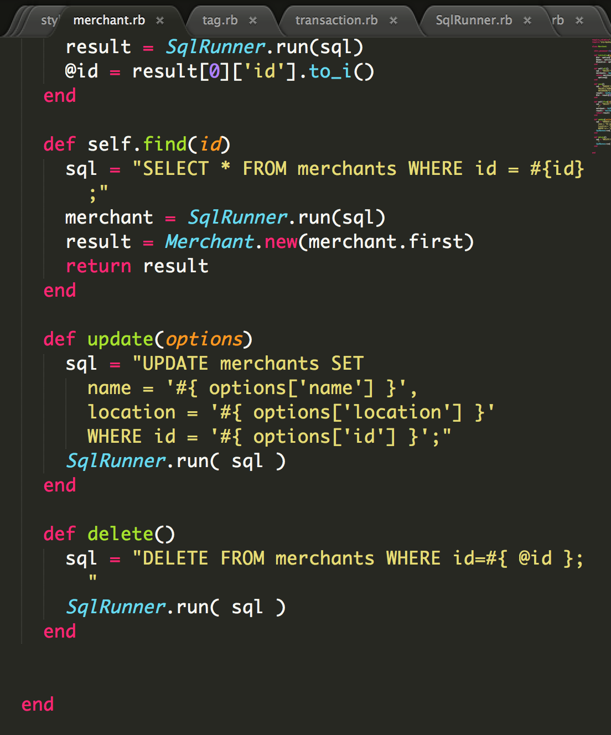

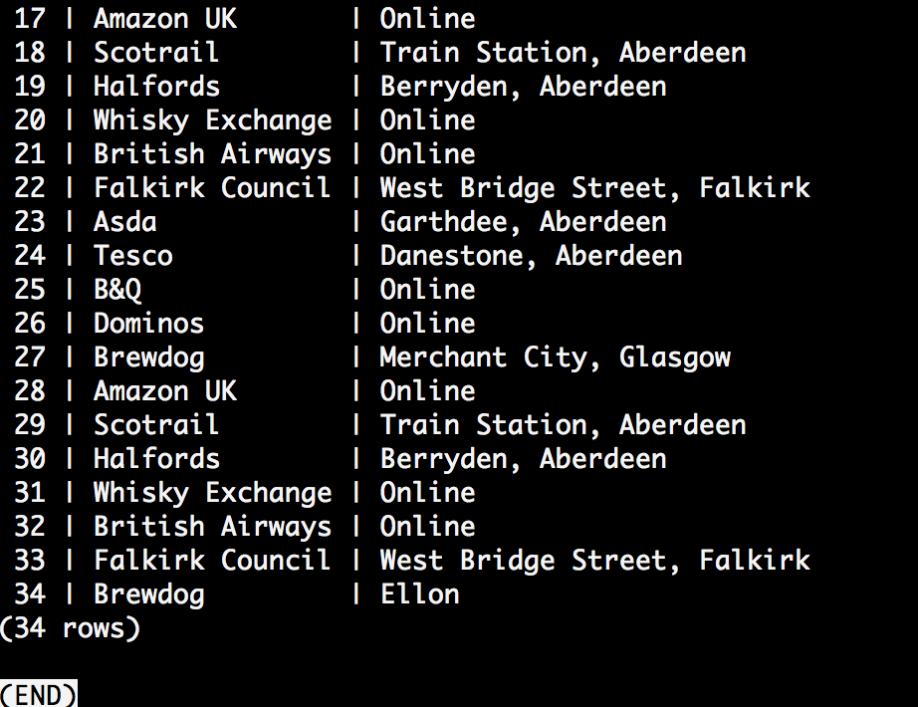

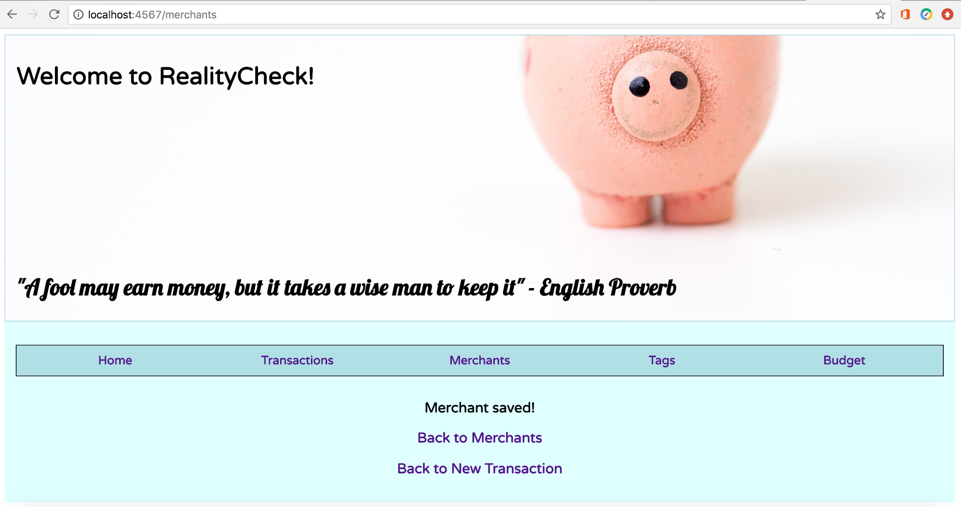

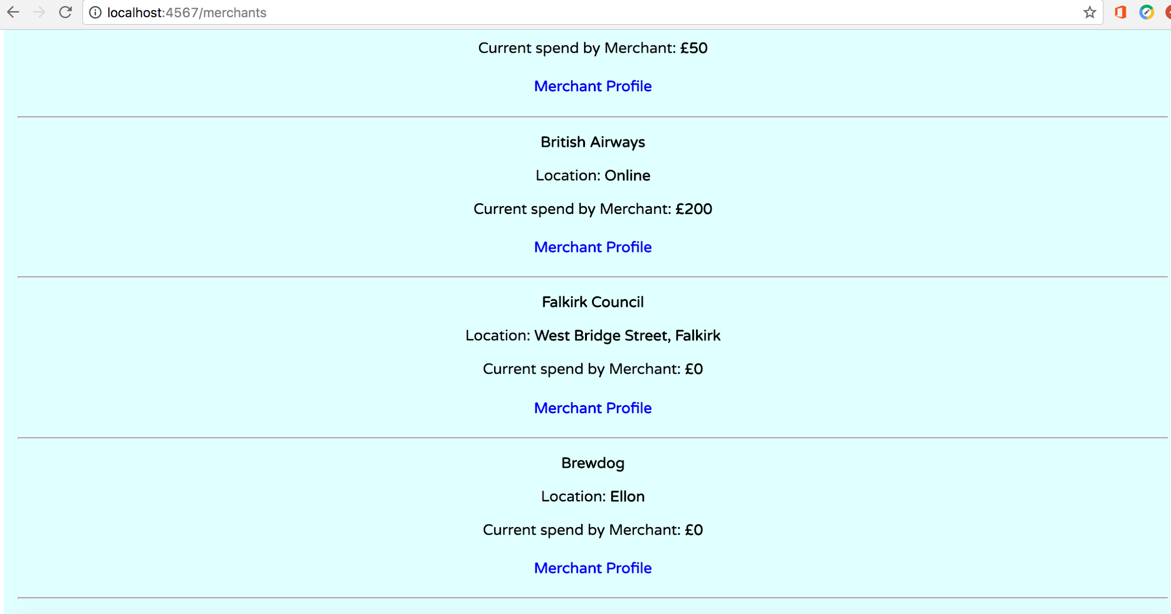

**Week 6:**  
  
Demonstrate the use of Polymorphism in a program:  
POLYMORPHISM

- Capacity to take on different forms.

- A language’s ability to process objects of various types and classes through a single, uniform interface.

- Example, how a parent class refers to a child class object

- Any object that satisifies more than one IS-A relationship is polymorphic in nature.

- Fair to say that every Object in Java is polymorphic in nature, each on passes IS-A test for itself and for Object class.

E.g. Animal class, Cat IS sub-class of Animal. Cat satisfies IS-A relationship of own type and its Super-class, Animal.

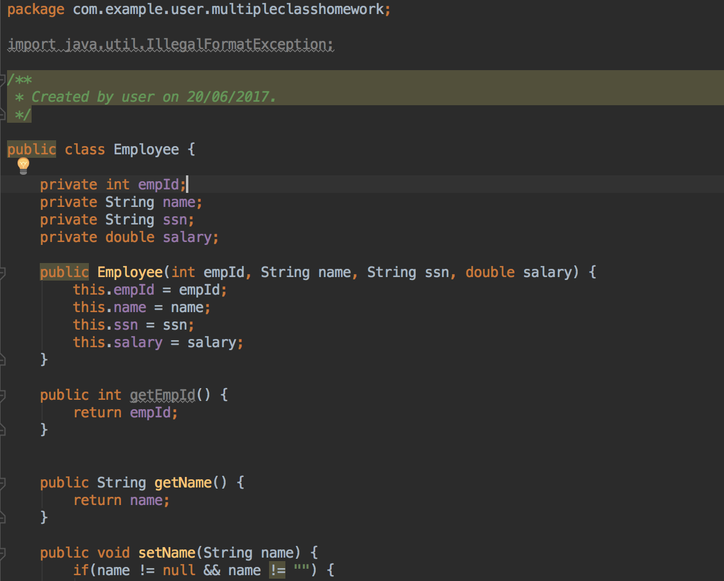

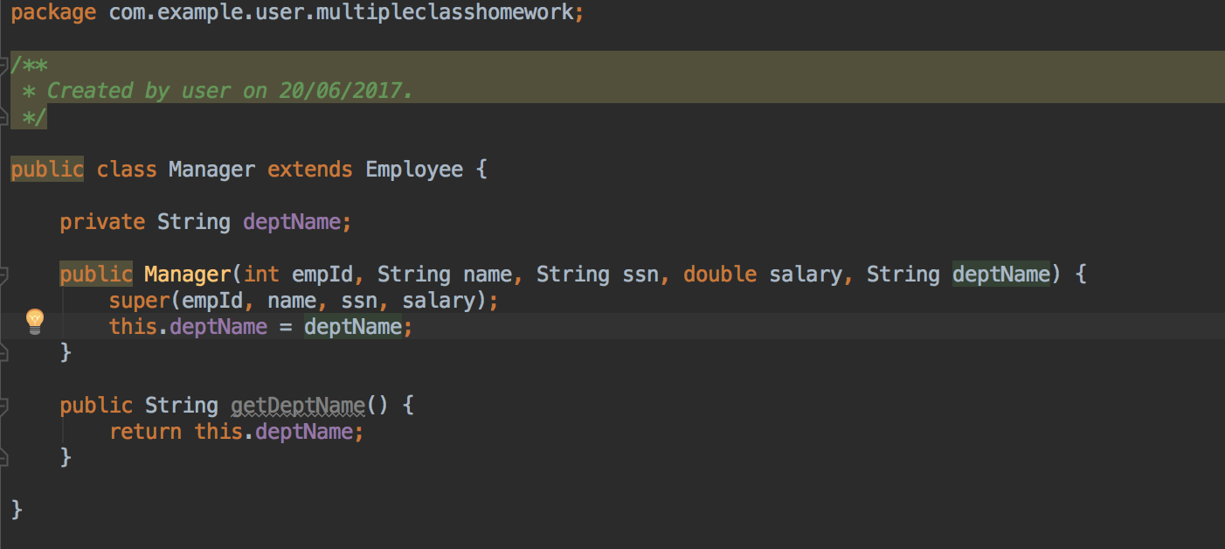

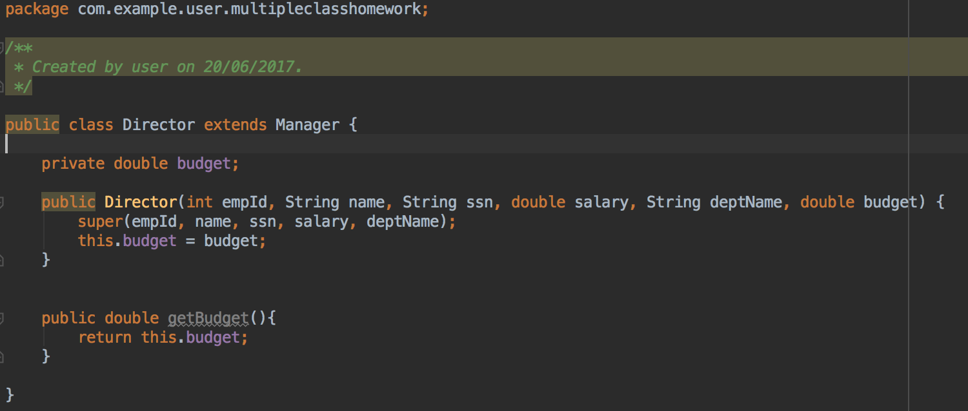

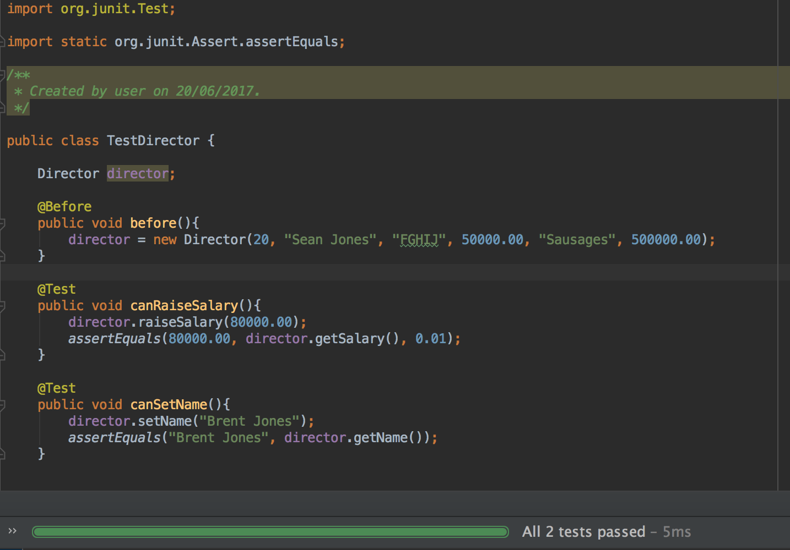

**Week 7:**  
*An Inheritance Diagram*  
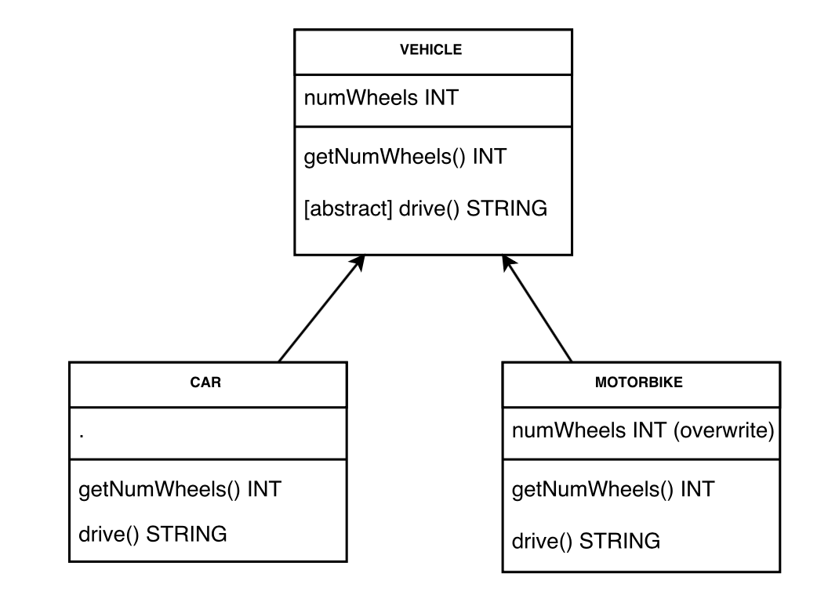

*Take a screenshot of an example of encapsulation in a program*

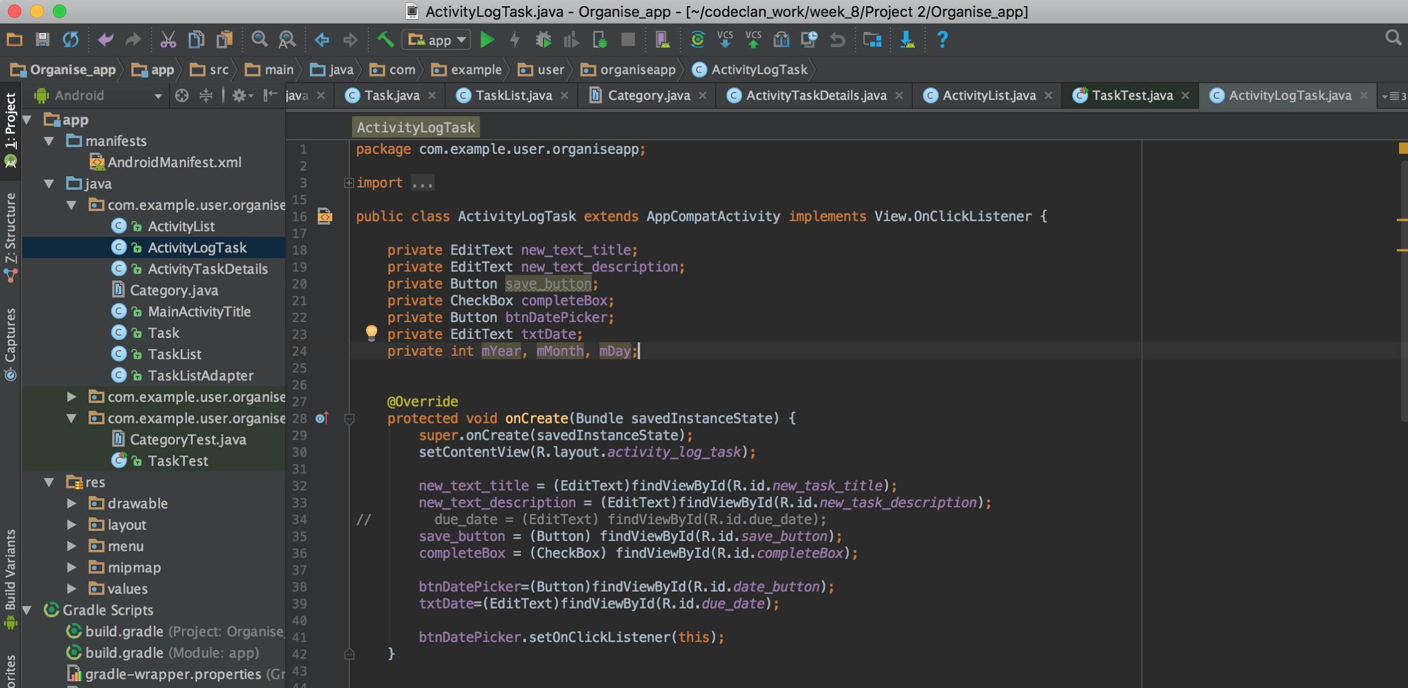

*Take a screenshot of the use of Inheritance in a program. Take screenshots of:   
*A Class  
*A Class that inherits from the previous class  
*An Object in the inherited class  
*A Method that uses the information inherited from another class.*

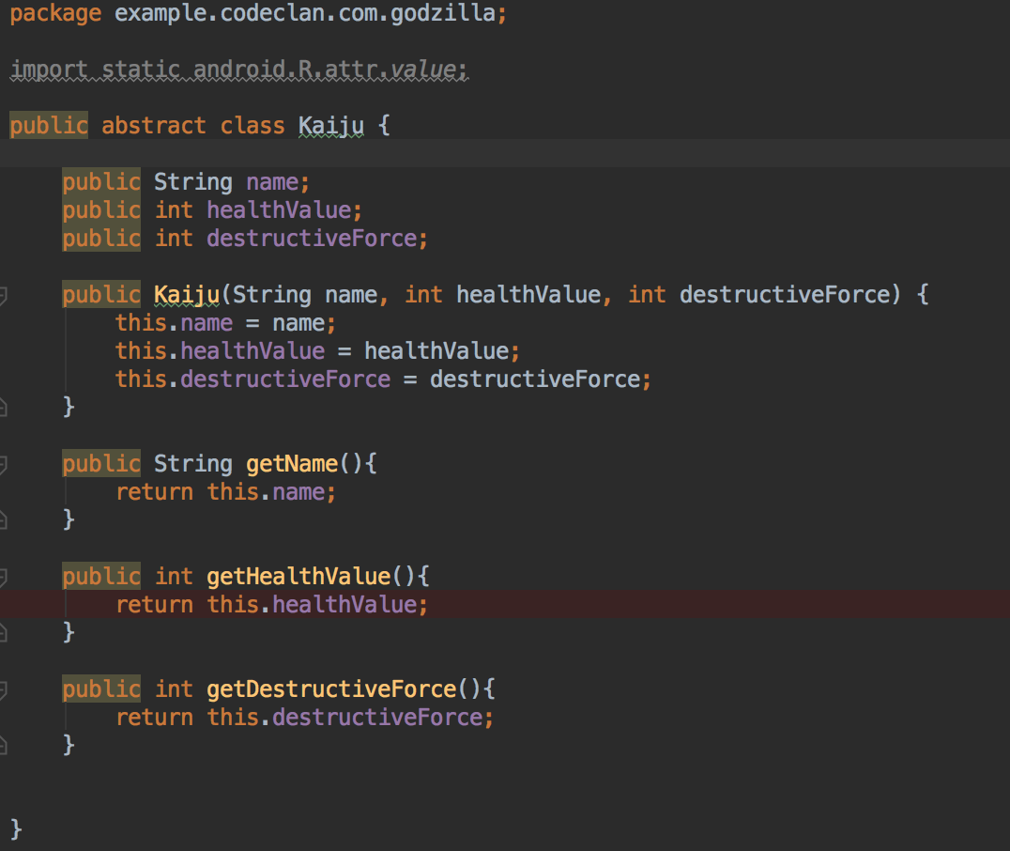

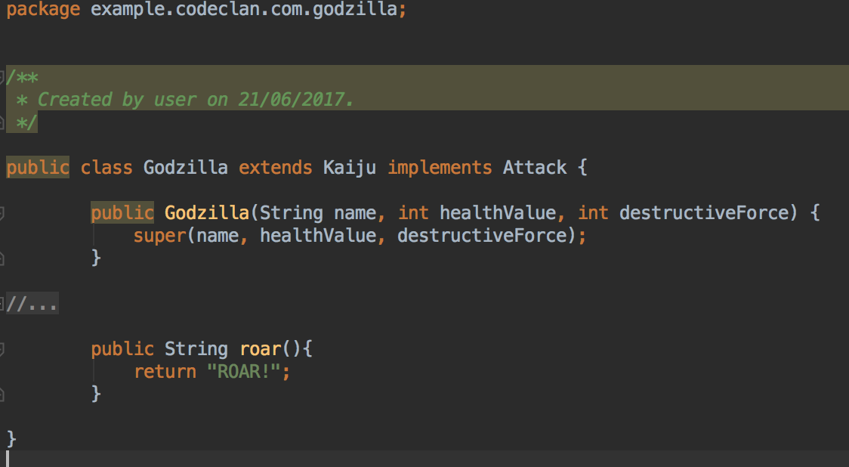

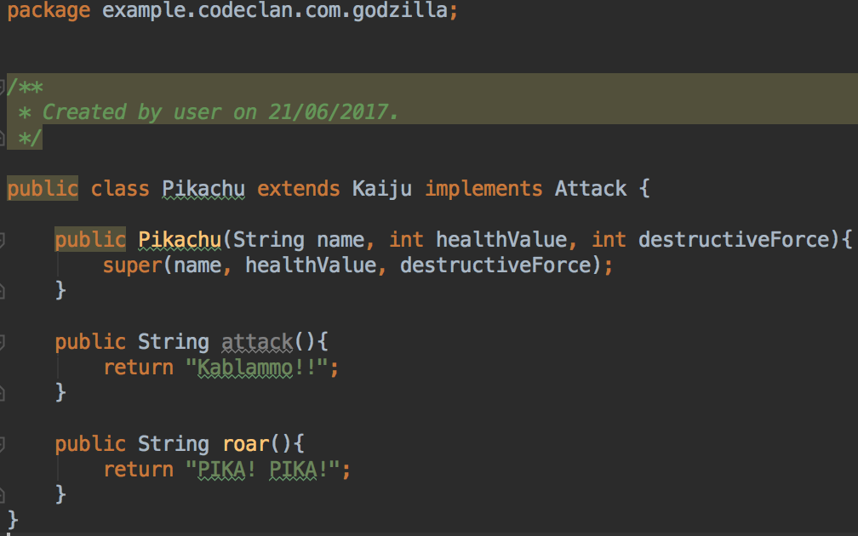

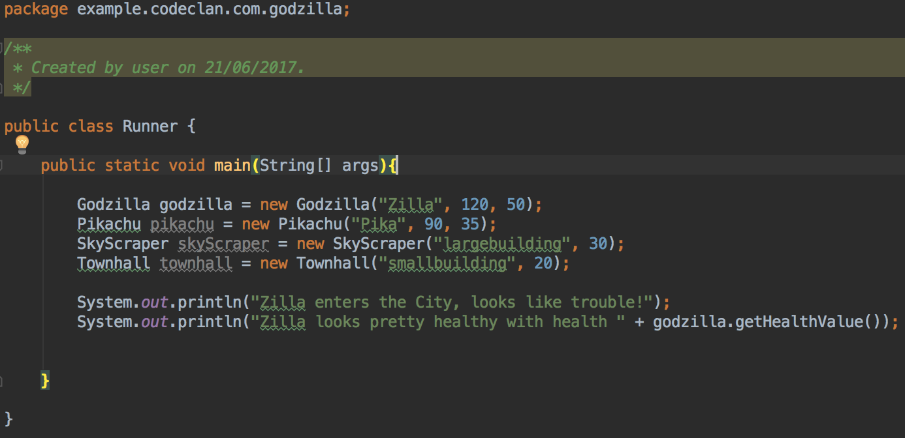

*Take a screenshot of one of your projects where you have worked alone and attach the Github link.*

<https://github.com/chris-burn/To-Do_list_project>

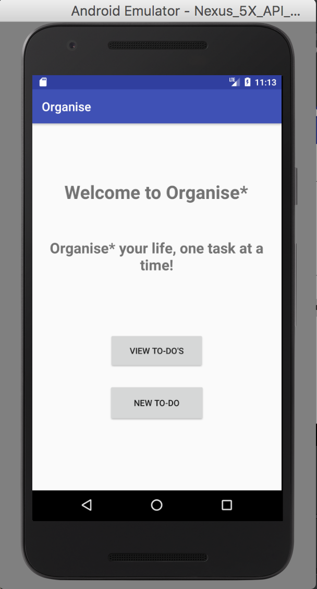 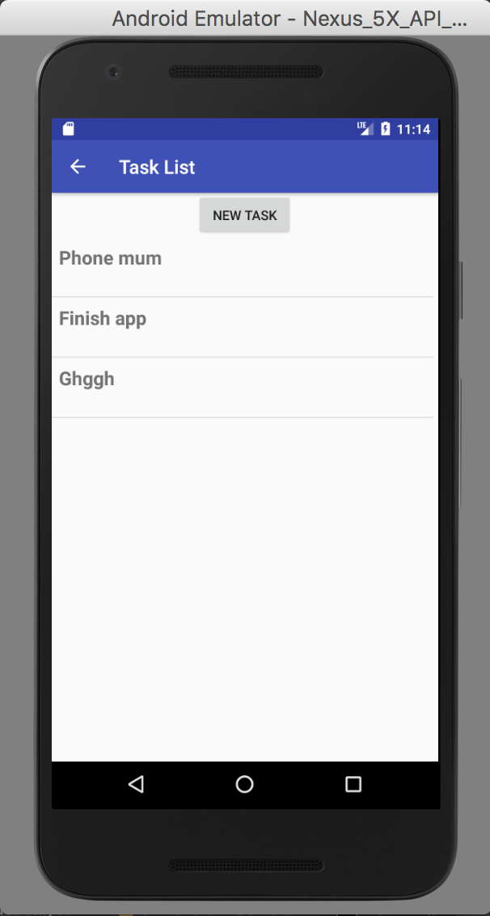 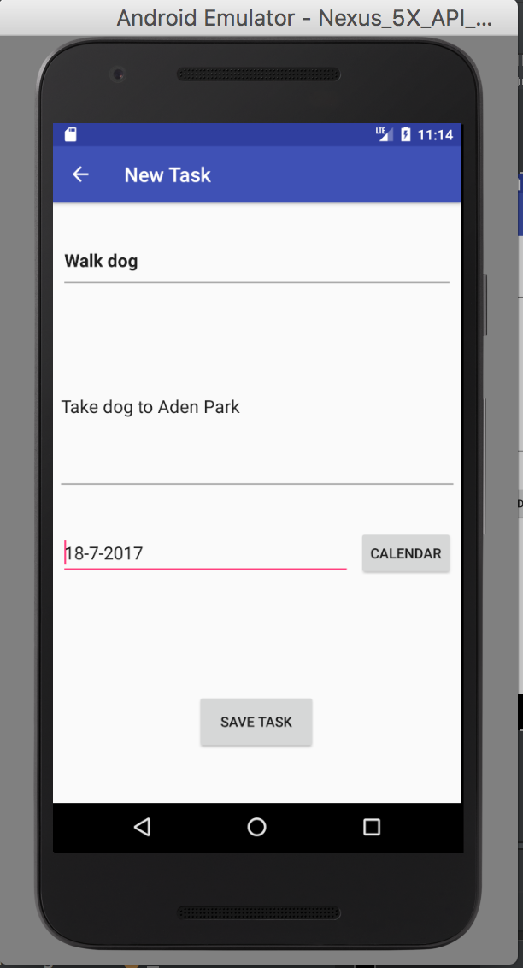

Take screenshots or photos of your planning and the different stages of development to show changes.

Android App, PROJECT PLANNING:

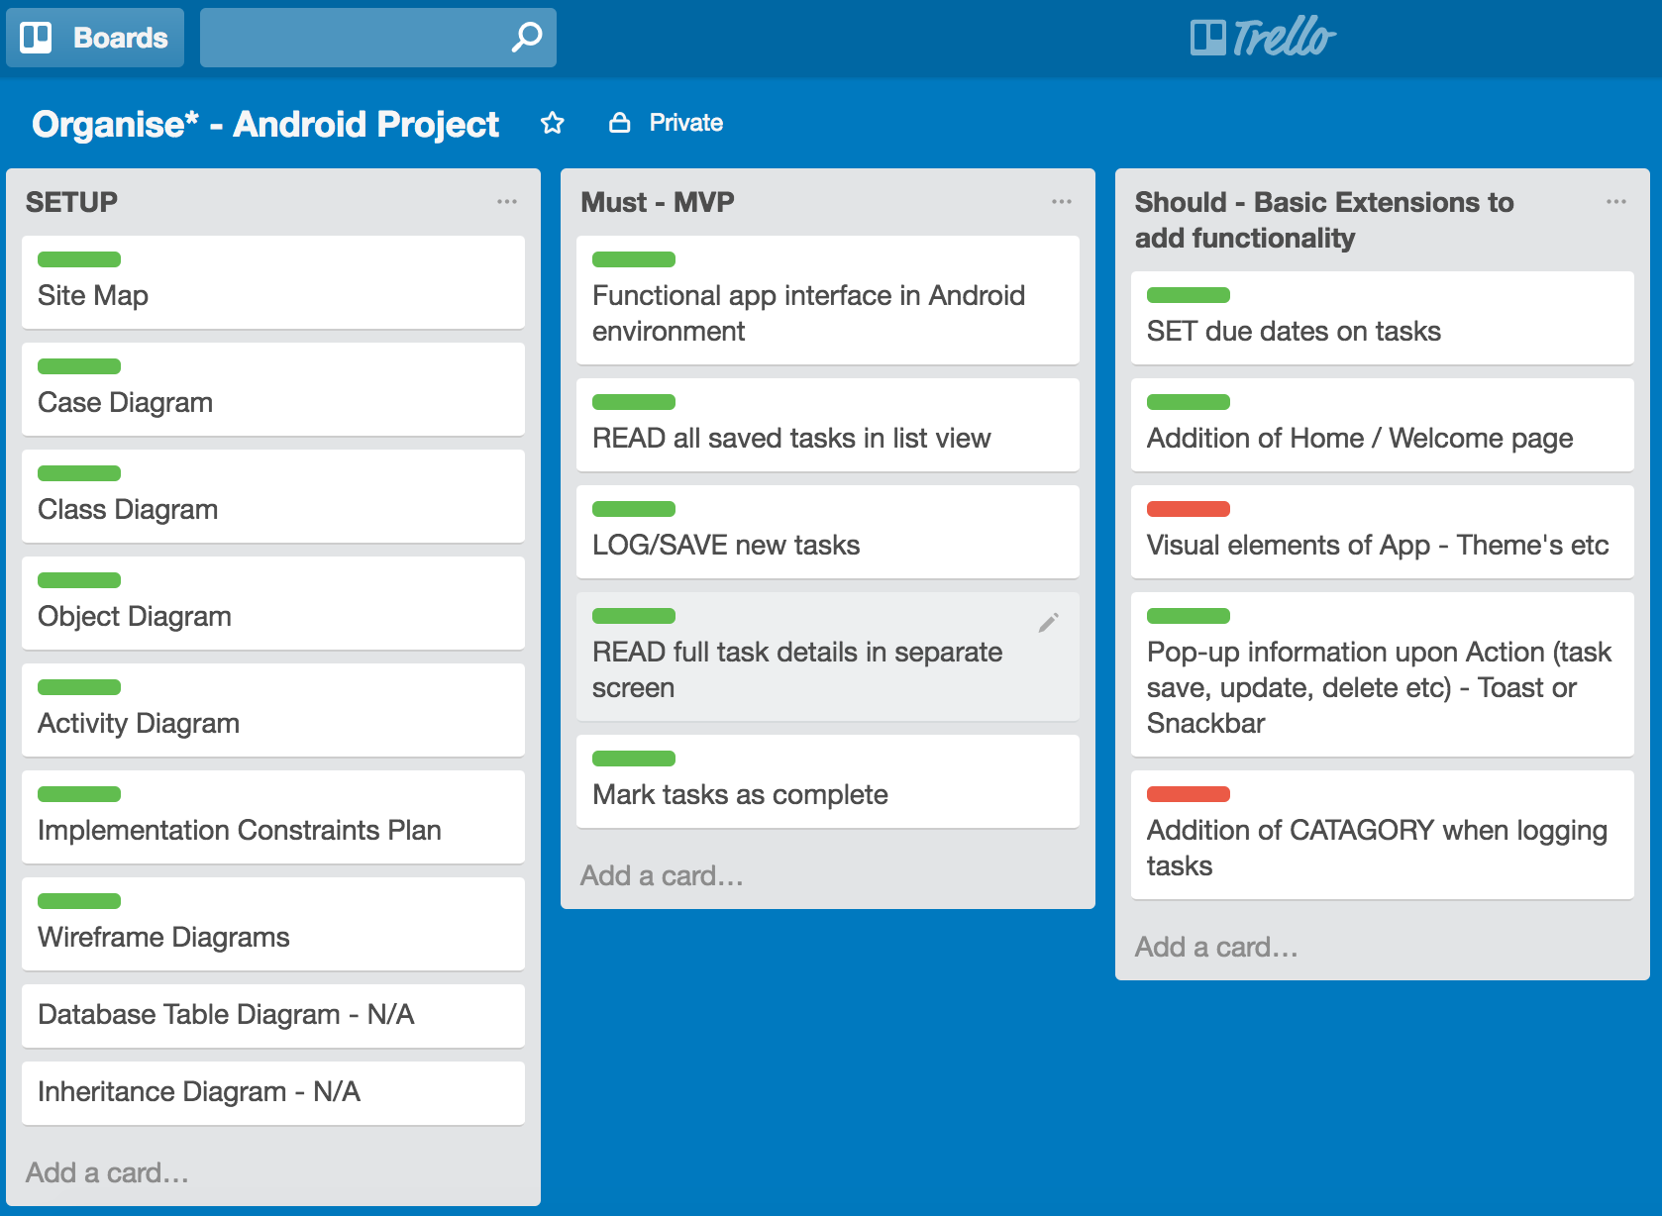

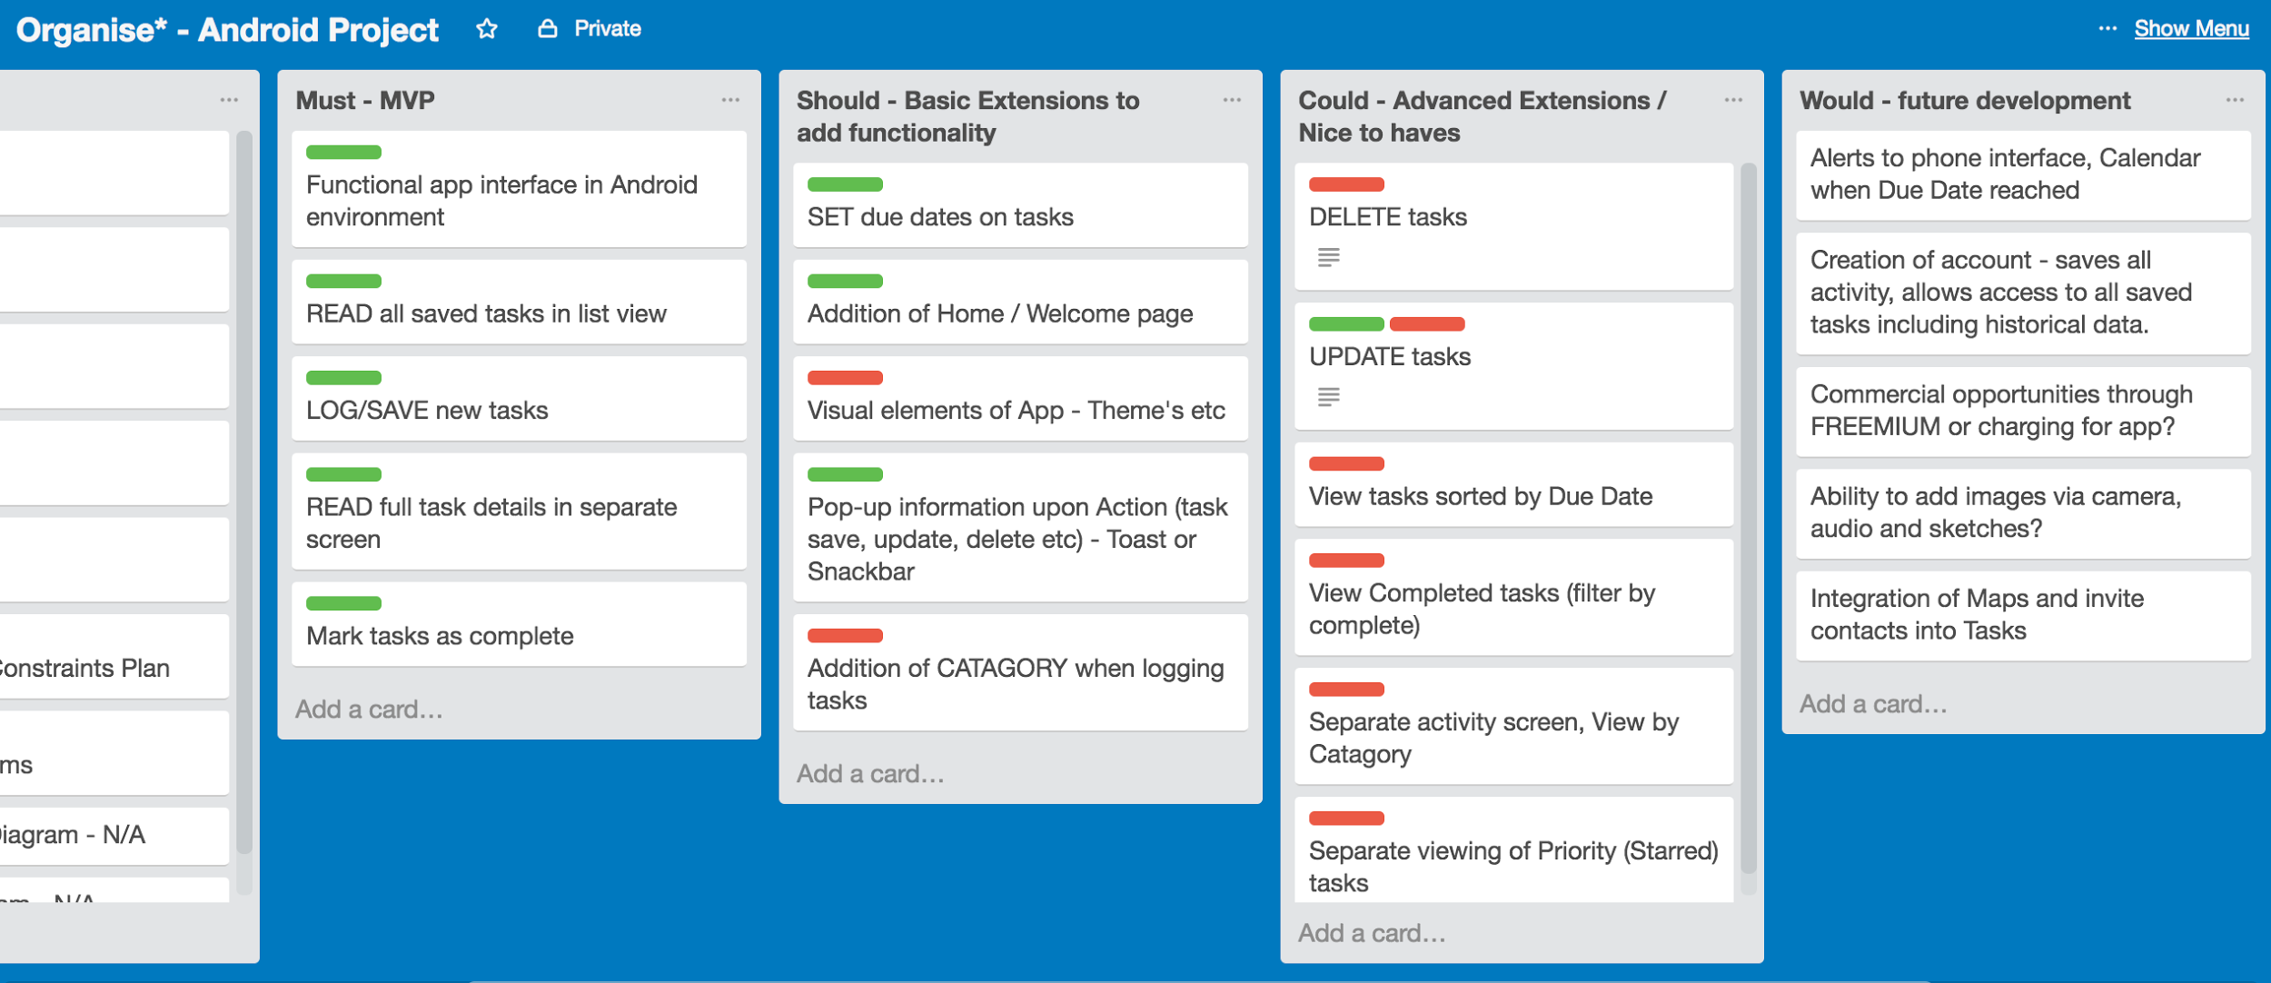

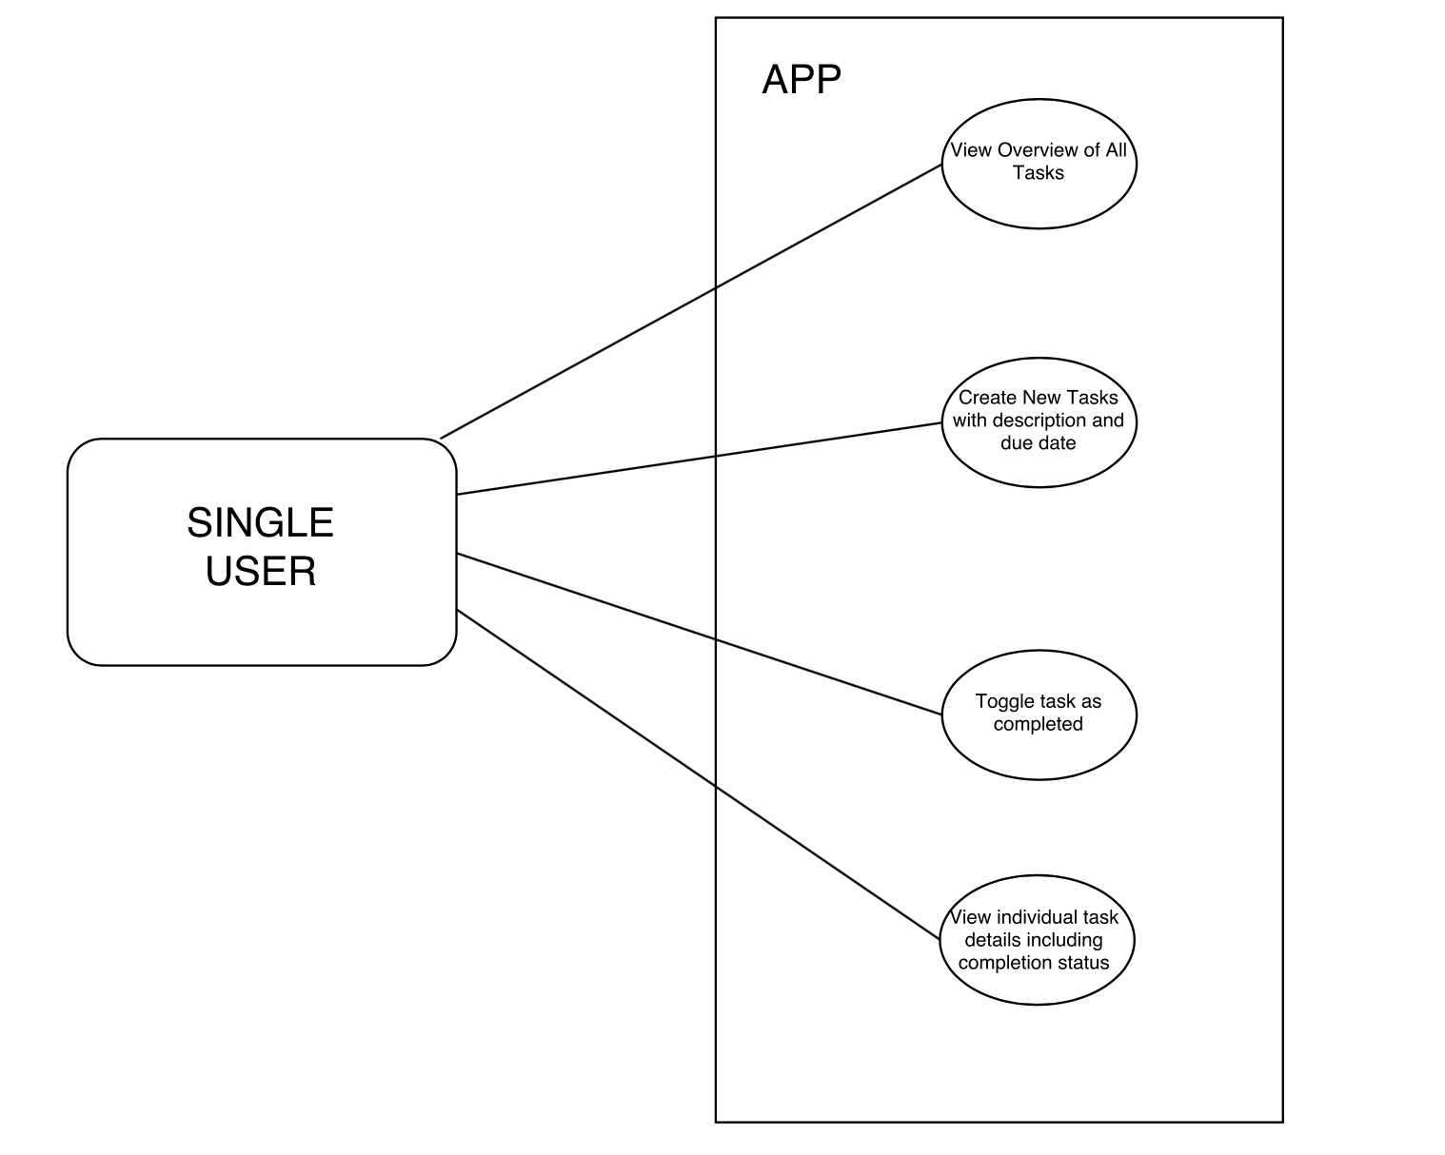

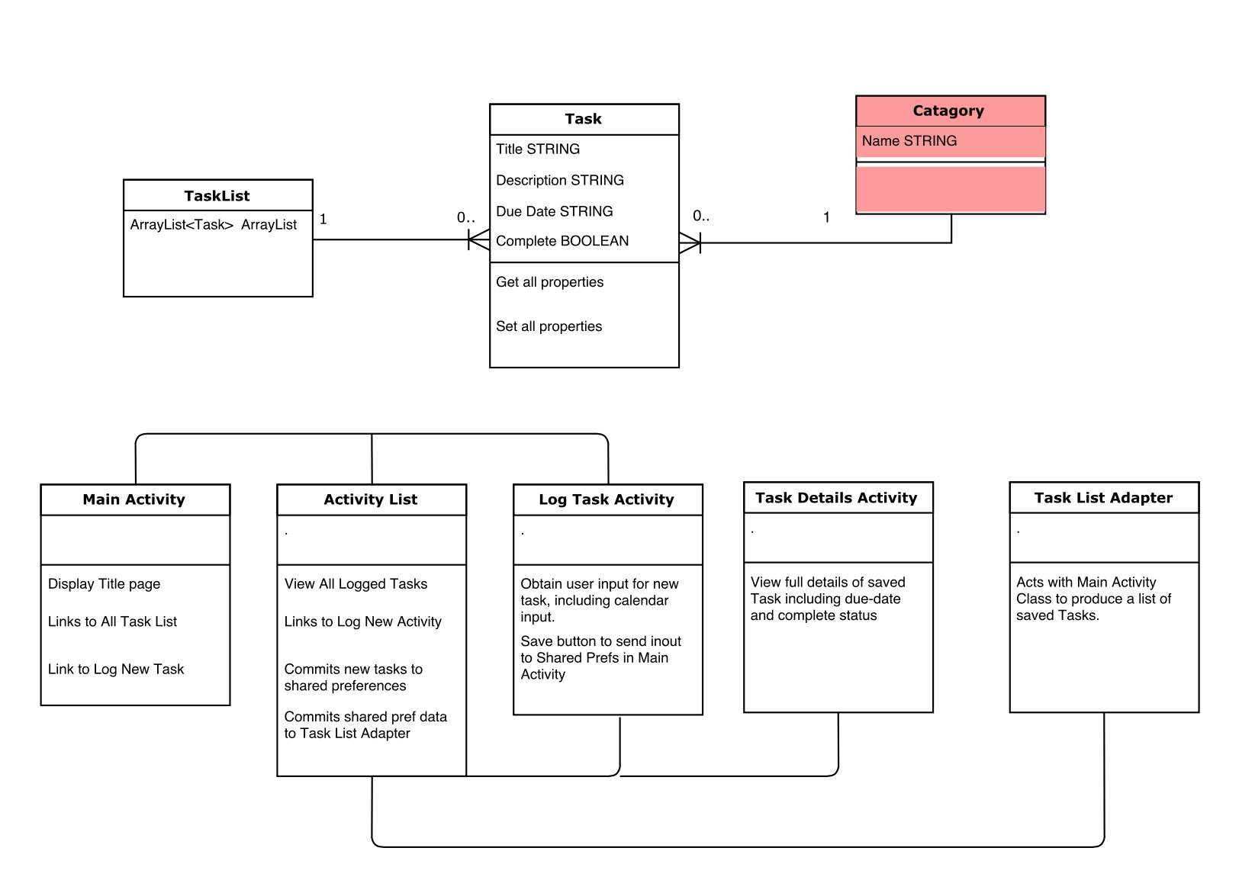

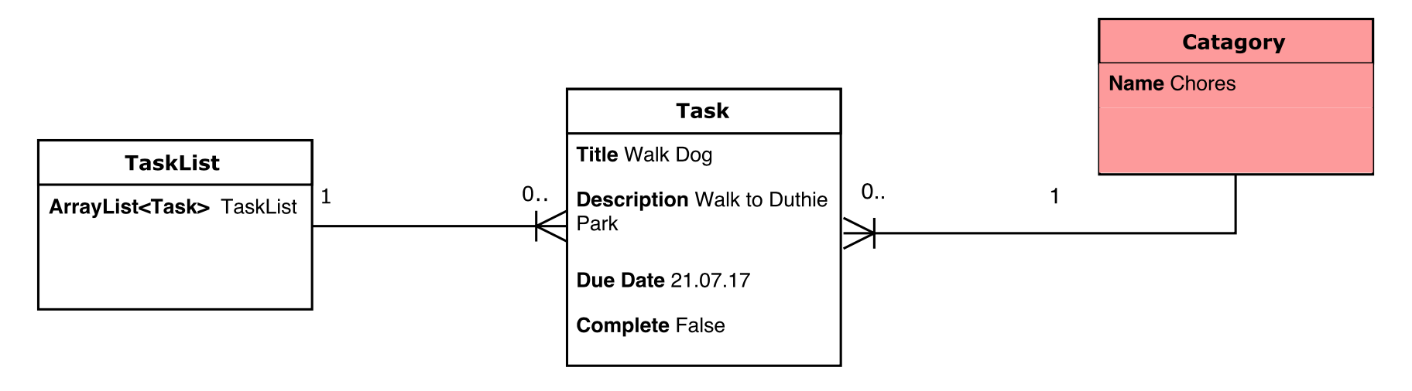

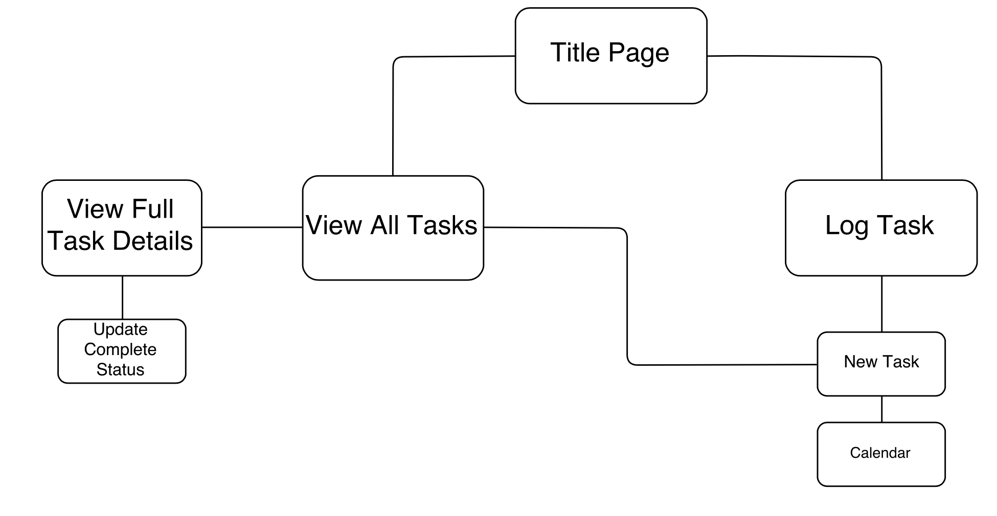

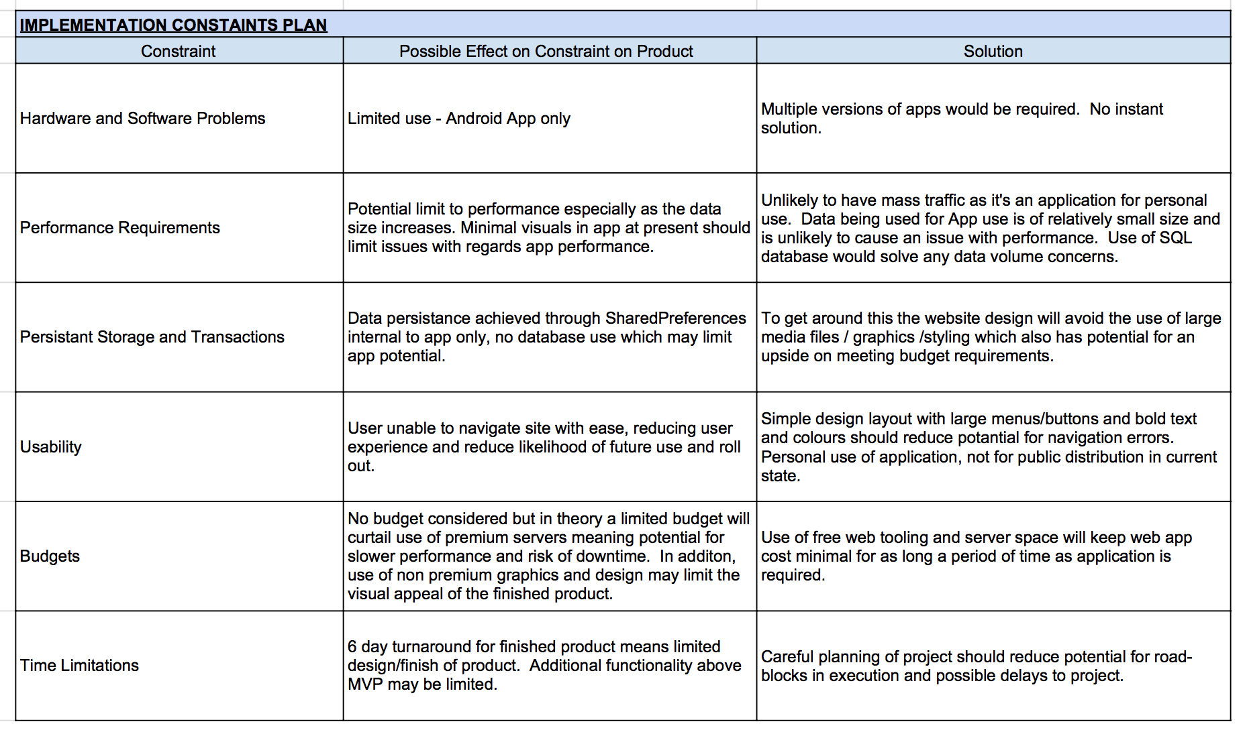

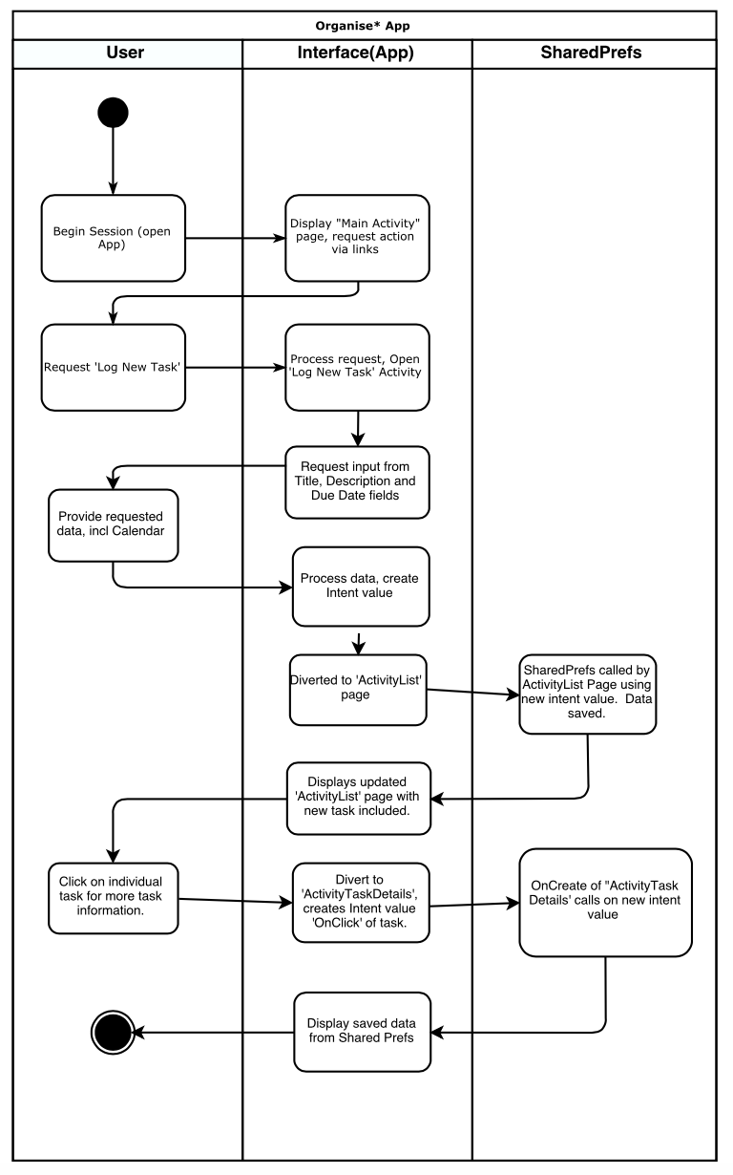

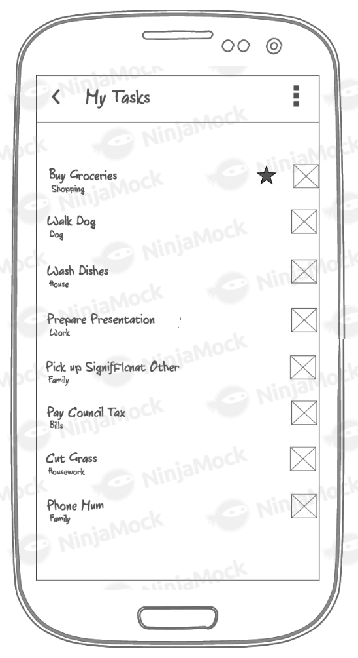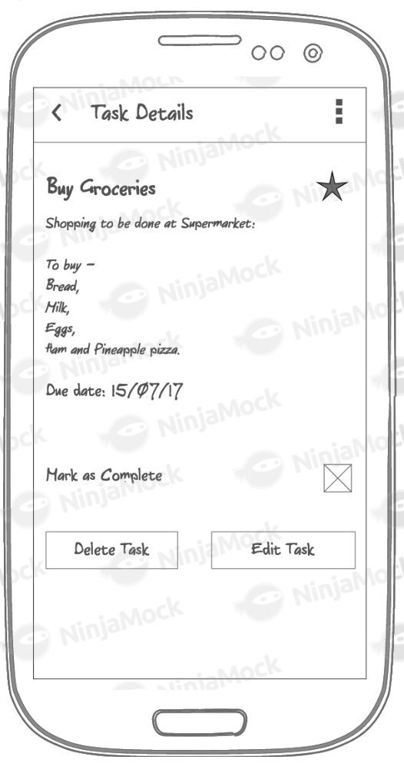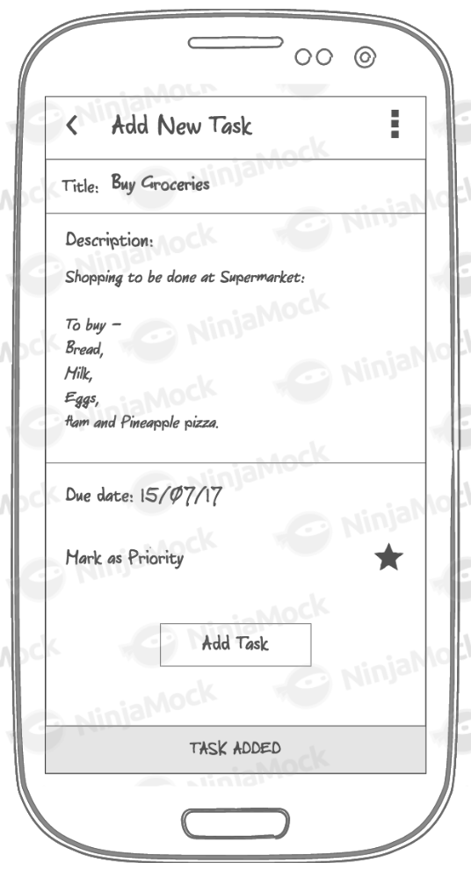

*Week 13: Algorithms*

*Select two algorithms you have written (NOT the group project). Take a screenshot of each and write a short statement on why you have chosen to use those algorithms.*

Weekend homework (Blackjack):

This method populates a ‘deck’ (ArrayList) with card types and numbers via a nested for loop which loops through a designated set of ENUMS for card type (suits) and loads the ArrayList with a connected set of ENUMS for card numbers. This means for each card type there are a set of card numbers. I.e. Hearts has an ArrayList of (Ace, 2, 3, 4 … King), as does Diamonds and Clubs. The result is an ArrayList of 52 cards (4 *13) which makes up the playing deck for the game of Blackjack.

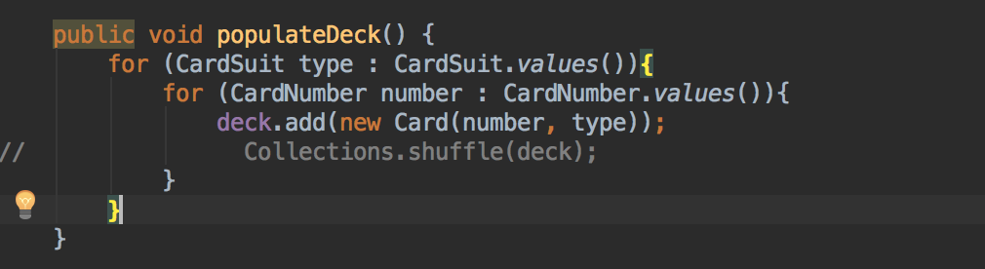

Weekend homework (WordCount Android App, homework):

This method is used to calculate the length of a String input from an EditText box. Setting a counter at the start of the method via the ‘words’ variable, the for loop iterates over the String and splits the string into separate characters via the split function. It then increments the word count for each input of a blank entry. The words variable is then converted to a String via another variable designation as required by the String method output.

